**Problem Statement :**

**Task 10:** Enhance the task 8 (refer session 19, assignment 1) to calculate the top 3 state-wise sales for each company. You may use multiple reducers for this activity.

**Solution:**

Driver Class:

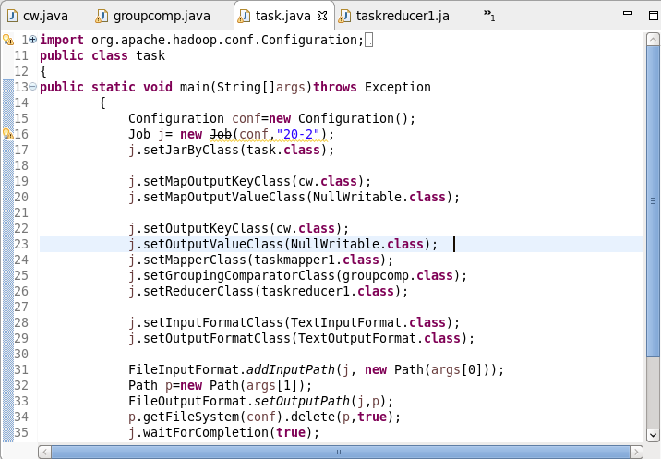

Mapper Class:

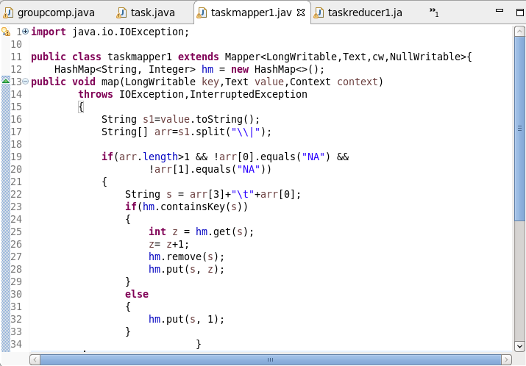

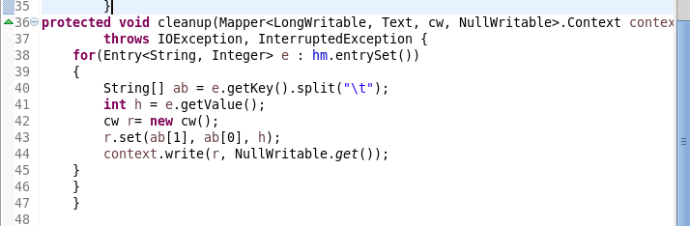

Reducer Class:

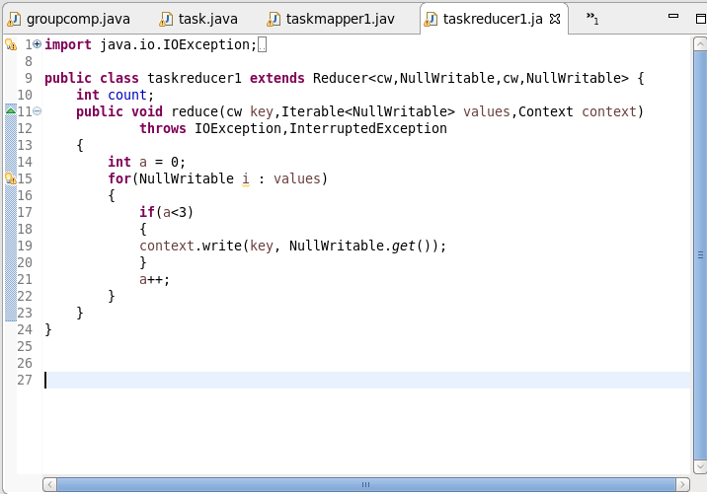

Writable Comparator Class:

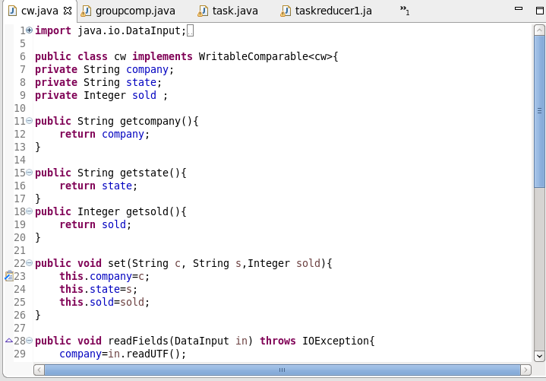:

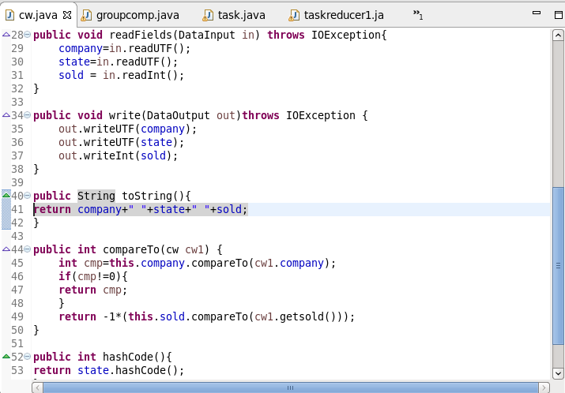

Group Comparator Class:

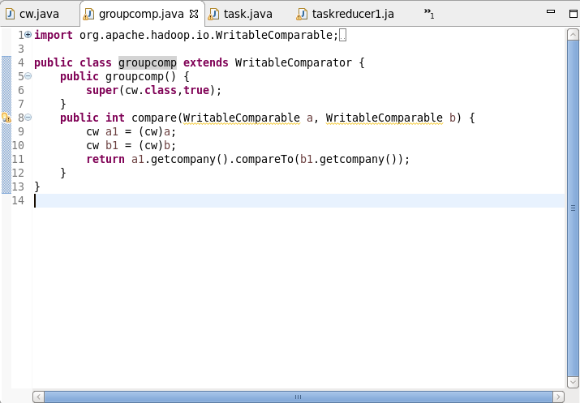

Execution Command:

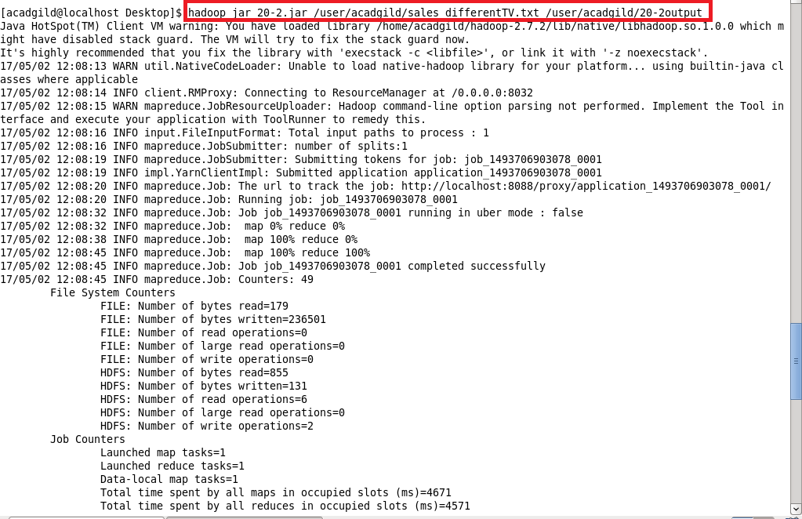

**Output:**

